ATTACHMENT 5: TURNING PROSPECTS INTO DONORS
Adapted from Source: De Mille, Andrew, 2005, Potential donors are people too!, Andrew de Mille Fundraising Consultants, viewed October 30, 2013, http://www.demille.co.uk/newssubs/donors.php
How do we convert information leads into actual human involvement? It invariably comes down to linkage - seeking out that special "someone" who can connect us to the potential donor. We need people in our charity's circle who can pursue and activate those linkages, taking advice from those closest to the potential donor on how best to approach them.
Our involved supporters (including friends, family, and past and current donors) should be asked to comb the prospect lists looking for connections – people who can introduce a prospective donor, who can inspire, motivate or somehow catch their deep personal interest.
Inviting potential donors to an open day or to tour a facility or meet some of the beneficiaries of a charity might start the process; alternatively a request to come and look at a particular problem and help advise on how to overcome it – these are the ways in which many donors may first become involved in the cause. Whether they represent a trust, a company, or come as individuals, we must remember that they are people!
Recent research in Why Rich People Give book has demonstrated some telling reasons for making six and seven figure donations. The research showed that donors wanted to:
- Make a difference and be a catalyst for change
- Be appreciated and respected for their support and the expertise which is the source of their wealth
- Be concerned with governance, effective management, and accountability
- Have relationships with senior staff in the recipient organization, including those who deliver the mission, ultimate beneficiaries (where appropriate) and other donors to reinforce the commitment to the cause and make giving enjoyable and fun.
It is clear that the cause must strike a sufficient chord to make the donor feel "I must help," but these conclusions show that potential donors should also be engaged discussions which gave them the opportunity to satisfy the four points above
More and more research may be one route to finding the key to a donor's motivation; but intelligent development of contact networks is far more likely to build an accurate picture of the prospect's personal interests and motivations. Research is essential, but also means going out and talking to real people!
Personal involvement is the key to support. The Tarn side Curve of Involvement is a series of key stages in donor prospect involvement against the likely level of gift. So long as the donor prospect is continuing to advance up the scale of involvement it is unwise to seek the gift; there will usually come a point where commitment is reaching at least a medium term peak – that is the moment to seek a financial commitment; more will follow if the giving experience is a good one, so develop and work on that relationship – not by sitting at a desk but by getting up and engaging with the prospective donor as an individual with preferences, pet peeves, a warm heart and a desire to make a difference to other less fortunate people's lives.
The further up the curve of involvement the prospective donor is, the greater the gift potential.
So what can the fundraiser do to reach this magical state of donor involvement?
- First – Stop staring at a computer and think about the real person behind the data.
- Second – find ways of engaging personally. This is usually best done through an intermediary, some mutual contact who has the respect of the potential donor and can encourage him or her to react positively.
- Third – remember that the research findings tell us that donors want to make a difference, feel that they have contributed more than just money, that they have added a unique expertise or element which has greatly improved the outcome.

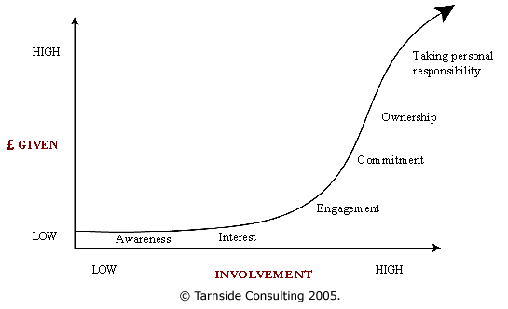
THE TARNSIDE CURVE OF INVOLVEMENT

Reward the Donor
At first thought, thanking the donor seems routine; after all, the donor has given their money at this point. What difference does a nice thank you make? The answer is: potentially a very big difference. Previous donors are more likely to make another donation to a charity than someone approached “cold.” Not only that, but repeat donors tend to give larger amounts than first-time donors.
Making the donor feel good about their donation will therefore have lasting effects, not only in terms of their future donations, but also in motivating them to “spread the word” and engage further with the charity, recruiting more people to get involved and widening the scope for donation.

- Encourage donors to “spread the word” on social media channels
- Reassure the donor that the donation has been successful and effective
- Encourage the donor to engage further with the charity
- Provide a prominent, personal thank you message.

